

Maker Challenge:

Create a bridge that will hold 5 Jenga blocks.

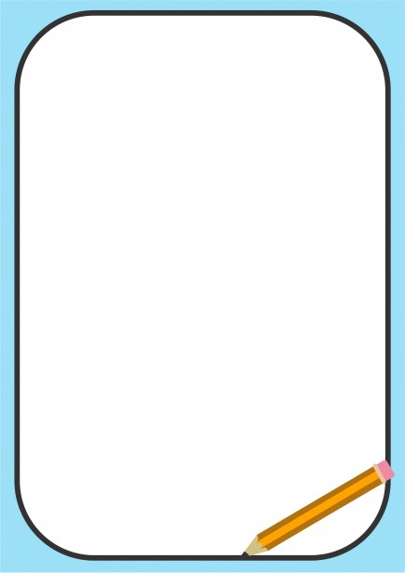

**Maker Challenge:**

**Create a zipline**

**that will carry a penny.**

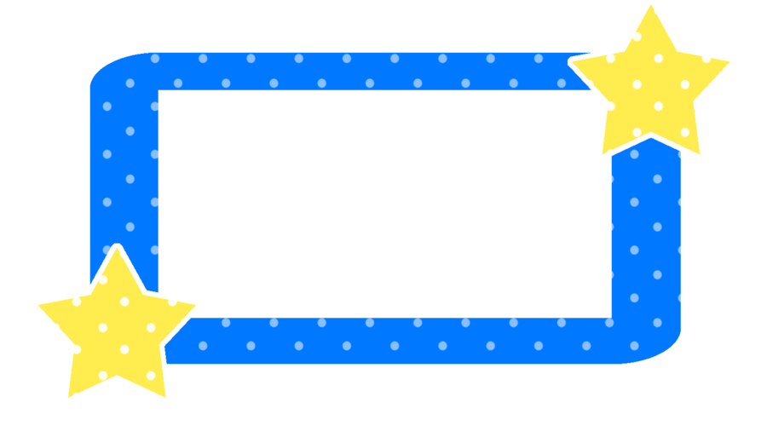

**Maker Challenge:**

**Create a catapult that will move a ping pong ball at least two feet.**



Maker Challenge:

Make a car with wheels that will roll.

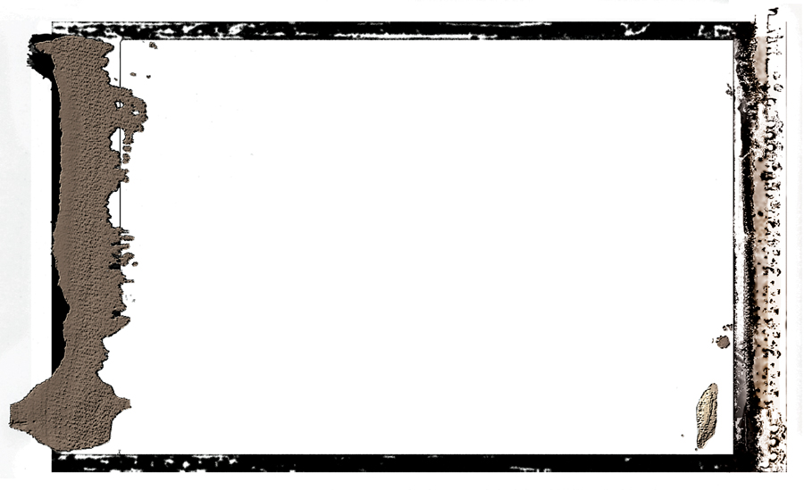

Maker Challenge:

Create a musical instrument.

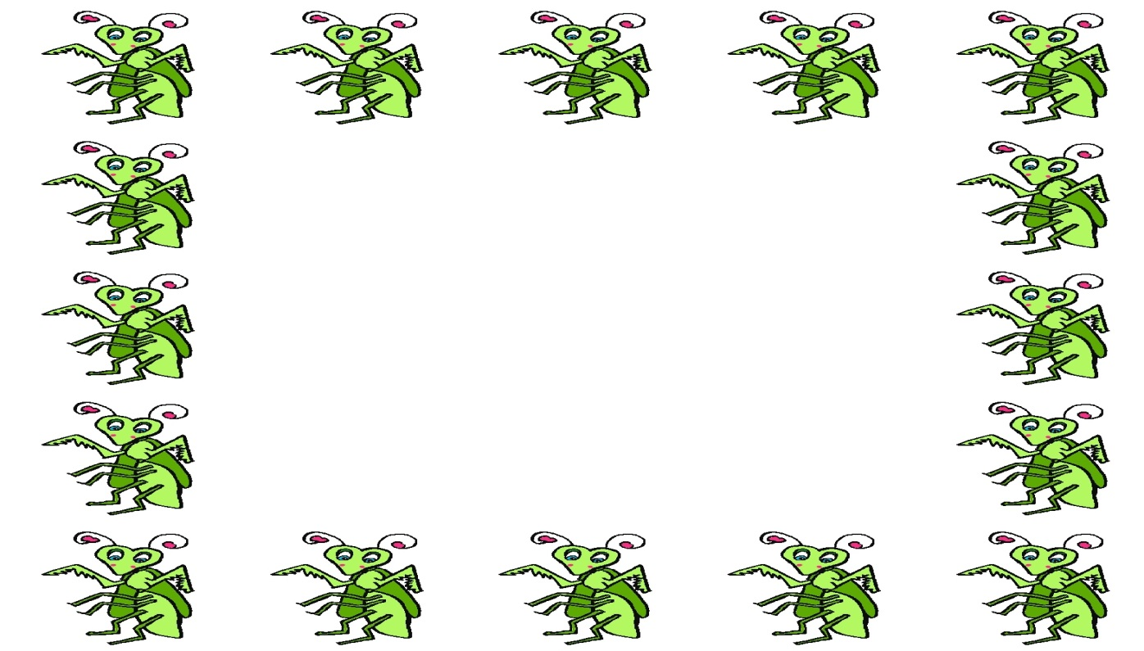

Maker Challenge:

Create a safe habitat for an insect.

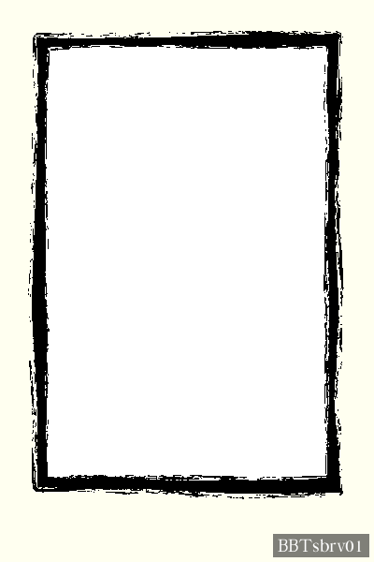

Maker Challenge:

Create a free standing tower that is at least

3 feet tall.



Maker Challenge:

Create a marble maze.



Maker Challenge:

Create a pulley system to move three pencils from one location to another.

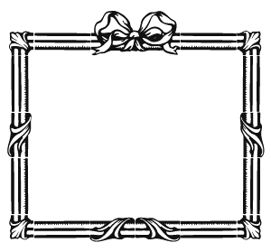

Maker Challenge:

Create a working pinball game.

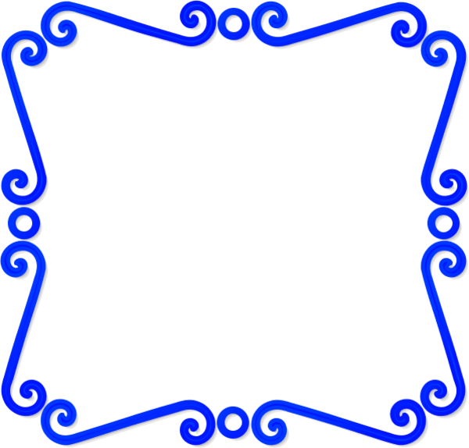

Maker Challenge:

Create a chair that will hold a stuffed animal.



Maker Challenge:

Create a piece of jewelry with a hidden message.

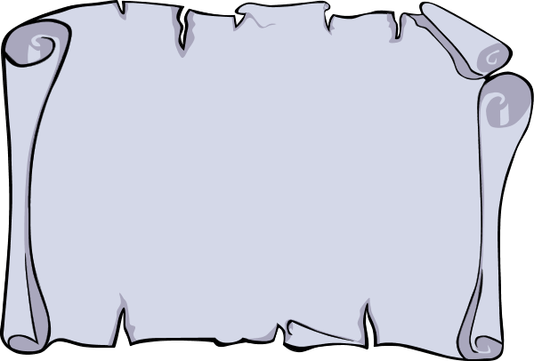

Maker Challenge:

Create a roller coaster that will carry a marble.

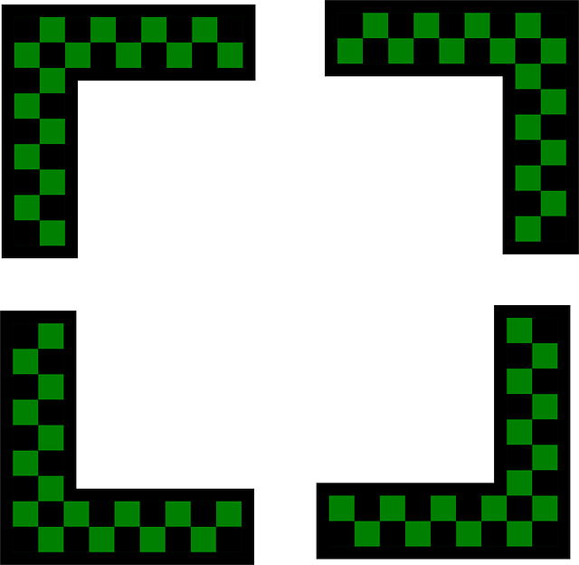

Maker Challenge:

Design a new uniform for Hillel students in lower school.

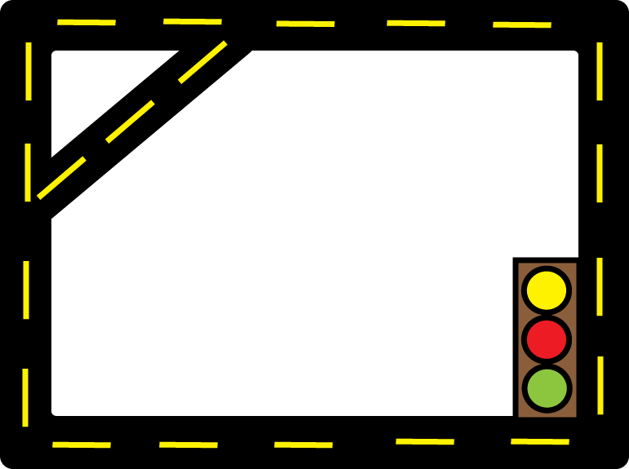

Maker Challenge:

Create a new mode of transportation.



Maker Challenge:

Create a game that helps students practice learning.



Maker Challenge:

Design a new type of kippot to alleviate problems Hillel students face.



Maker Challenge:

Create something to solve a problem you face daily.



Maker Challenge:

Create an adjustable jump that the Sphero Ollie can use.



Maker Challenge:

Repurpose a puzzle to make a new game or puzzle.



Maker Challenge:

Create a bird feeder or a birdhouse.



Maker Challenge:

Recreate a piece of artwork out of Legos.



Maker Challenge:

Create a safe to hide your valuables.



Maker challenge:

Create a jewelry box.



Maker Challenge:

Create a cardboard piñata.



Maker challenge:

Create a portable student desk.