B”H
My Travel
Journal

Grades K-2

by:
_________________________________

Class: __________________________

Date: _________________________
In Hebrew and English

Country: ______________________________
In Hebrew and English
B”H

THE TRAVELER’S PRAYER

יְהִי רָצוֹן מִלְפָנֶיךָ יְ-יָ אֱ-לֹהֵינוּ וֵא-לֹהֵי אֲבוֹתֵינוּ. שֶׁתּוֹלִיכֵנוּ לְשָׁלוֹם. וְתַצְעִידֵנוּ לְשָׁלוֹם. וְתַדְרִיכֵנוּ לְשָׁלוֹם. וְתִסְמְכֵנוּ לְשָׁלוֹם. וְתַגִּיעֵנוּ לִמְחוֹז חֶפְצֵנוּ לְחַיִּים וּלְשִׂמְחָה וּלְשָׁלוֹם. (ואם דעתו לחזור מיד אומר:וְתַחֲזִירֵנוּ לְשָׁלוֹם). וְתַצִילֵנוּ מִכַּף כָּל-אוֹיֵב וְאוֹרֵב וְלִסְטִים וְחַיּוֹת רָעוֹת בַּדֶּרֶך. וּמִכָּל פֻּרְעָנִיּוֹת הַמִּתְרַגְּשׁוֹת וּבָאוֹת לָעוֹלָם. וְתִשְׁלַח בְּרָכָה בְּכָל מַעֲשֵׂה יָדֵינוּ. וְתִתְּנֵנִיּ (בל' יחיד) לְחֵן וּלְחֶסֶד וּלְרַחֲמִים בְּעֵינֶיךָ וּבְעֵינֵי כָל רוֹאֵינוּ. וְתִגְמְלֵנוּ חֲסָדִים טוֹבִים. וְתִשְׁמַע קוֹל תְּפִלָּתֵינוּ. כִּי אַתָּה שׁוֹמֵעַ תְּפִלַת כָּל פֶּה: בָּרוּךְ אַתָּה יְ-יָ שׁוֹמֵעַ תְּפִלָה:

May it be Your will, G-d, our G-d and the G-d of our fathers, that You should lead us in peace and direct our steps in peace, and guide us in peace, and support us in peace, and cause us to reach our destination in life, joy, and peace (If one intends to return immediately, one adds: and return us in peace). Save us from every enemy and ambush, from robbers and wild beasts on the trip, and from all kinds of punishments that rage and come to the world. May You confer blessing upon the work of our hands and grant me grace, kindness, and mercy in Your eyes and in the eyes of all who see us, and bestow upon us abundant kindness and hearken to the voice of our prayer, for You hear the prayers of all. Blessed are You G-d, who hearkens to prayer.

B’H
Wow you are getting to travel and see more of the world! Congratulations! While you are gone, you should fill out this travel journal with your parents about your amazing experiences. While this journal is REQUIRED for students who are traveling, we also want it to be a fun family experience. You may draw pictures, paste photographs, or write words to describe your trip. We want to be able to see your journey, just like you saw it! Please make sure you give Tzedakah on your trip!

When you return to school you will tell your class all the amazing and fun times you had. You may share souvenirs and artifacts picked up along the way. Do not create a presentation, just share your memories! We are excited to hear about your trip!

Once you have presented to the class, please bring your travel journal to the media center where others will read your journal to learn about your vacation.
B”H
Travel Route
Show the way you traveled from Florida to your destination.

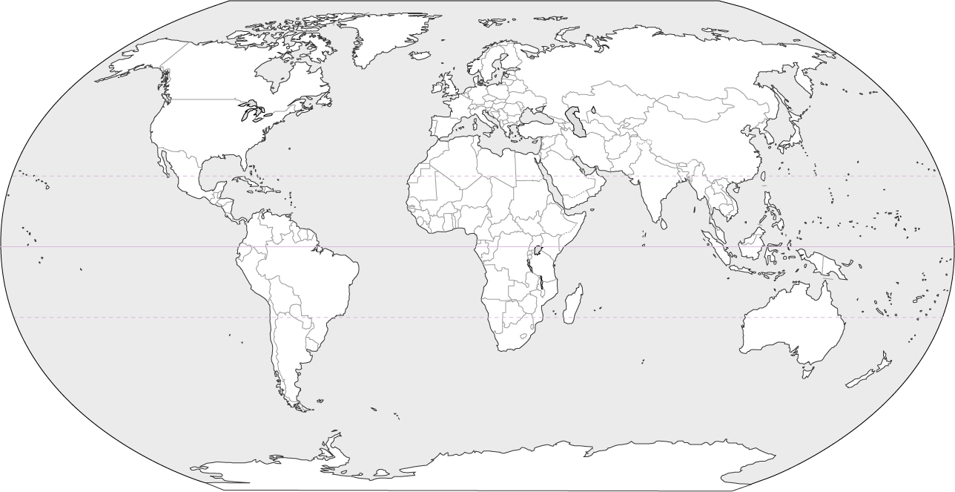

B”H
Transportation
How did you travel while on your journey?
Planes, trains, automobiles, boat, bike?

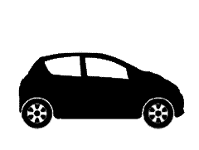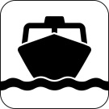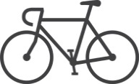

Tell us a funny story about traveling on this trip!
You can also attach a copy of your tickets!
Did you read your Traveler’s Prayer?
B”H
Accommodations
Where did you stay on this exciting voyage? Tell us about the house, hotel, ship, or other lodging you used.
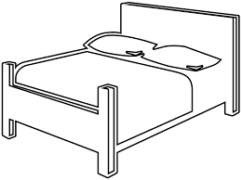
B”H
Food
What kinds of food did you eat while on your trip? What did you like? What was something new? Was there something you didn’t like? Which Jewish cultural foods did you eat? We want to know!
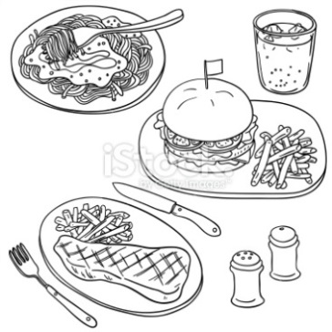

B”H
Activities
What were some of the fun things you did on the trip? What did you not enjoy? Did you do a Mitzvah project with your family on your trip?

B”H
Interesting People
Who did you meet on the trip that made the trip better? Was there a great cab driver, waiter, friend, or family member you got to see? Tell us about the people and why they were interesting.

B”H
Historical Landmarks
What part of history did you see on your trip? Were there any courthouses, Jewish museums, monuments, statues, important events in the area? Did you visit a synagogue?
Tell us about the Jewish history in the town or city! When was the Jewish community founded in this area? How many Jewish people are living here today?
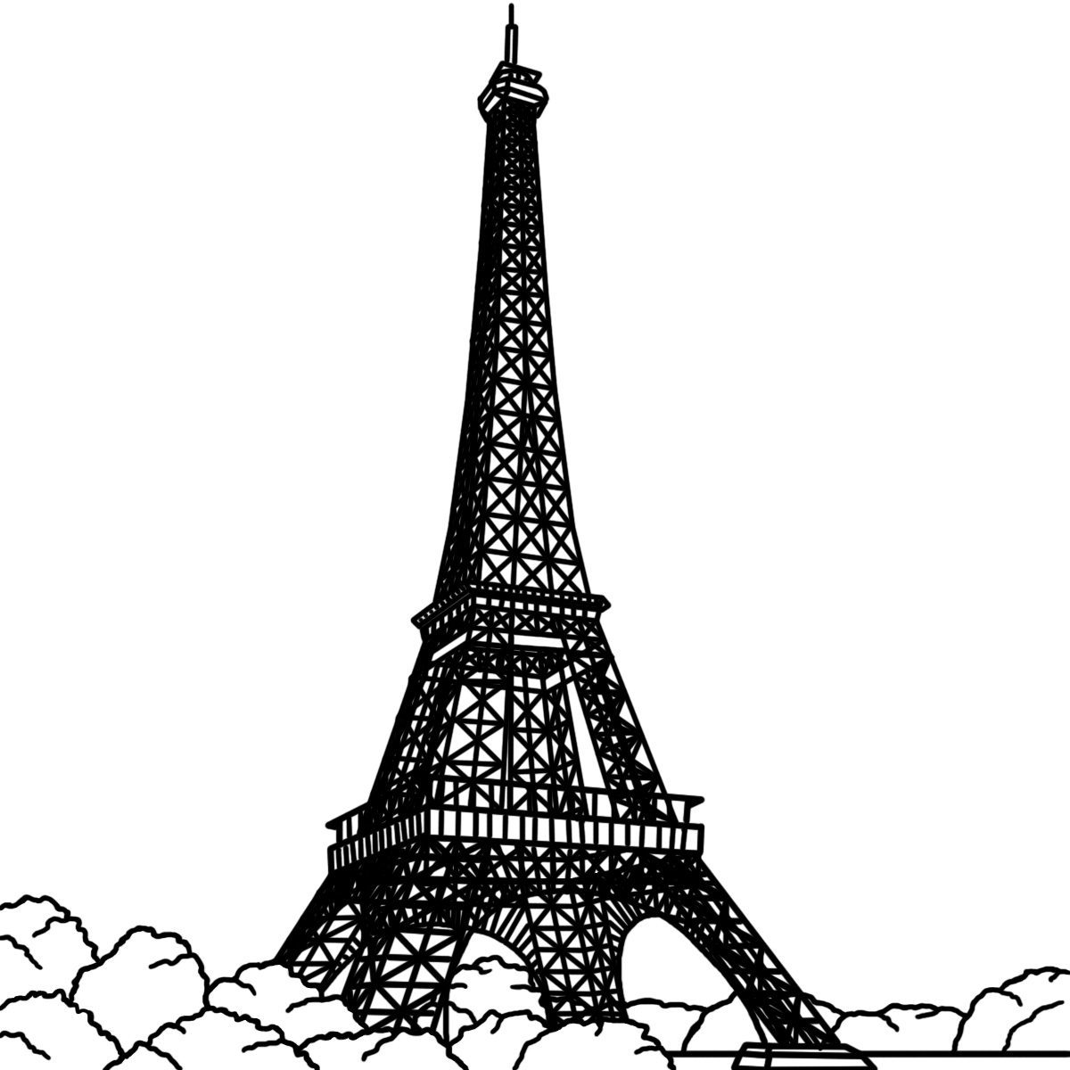
B”H
Weather
What was the weather like on your trip? Did you change your visit due to the weather? Was the heat good for swimming? Was the cold good for skiing? If you can find a weather chart, attach it!
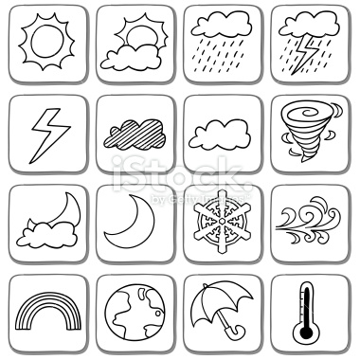

B”H
Let’s Go Again!
What are three reasons you want to return to this place? Explain why.

B”H
Fact Sheet
Whether you visited another city in Florida, another state in the United States, or another country- answer the facts!

What is the capital? ___________________________

What is the population? ________________________

How many Jewish people live here? ___________________________

Are the Hebrew prayers different in this country?
__________________________________________________________

How many miles is it from your location to Hillel? __________________

Who are two famous people from this area?
__________________________________________________________

Which languages can you hear being spoken in this area?
__________________________________________________________

How do people spend Shabbot here?
__________________________________________________________

B”H

Fact Sheet
Whether you visited another city in Florida, another state in the United States, or another country- answer the facts!
Draw or print and paste the flag that represents the place you are visiting.

Find a piece of money for the area and attach it. If you are visiting another state, find the state quarter and attach it.
B”H
Postcard Page
Attach one or more postcards from your travels. Tell why you selected this postcard.

